**Task 2:**

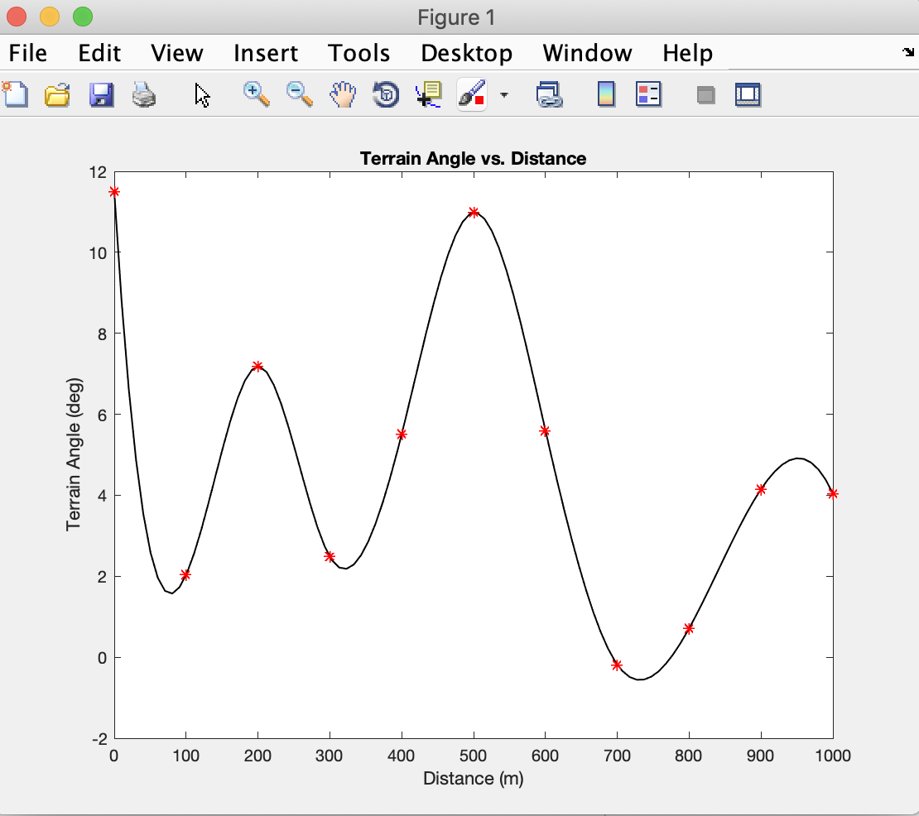

*Figure 1: Terrain Angle vs. Distance Graph*

As shown in the figure above, the terrain angle changes with relation to the distance the rover has covered. The changes in terrain angle may be due to mountainous terrain, which would require the rover to change angles based on the slope of the terrain it was encountering. As shown by the different fluctuations, the terrain has different amounts of slope over different distances resulting in the terrain angle change as the distance increases.

**Task 5:**

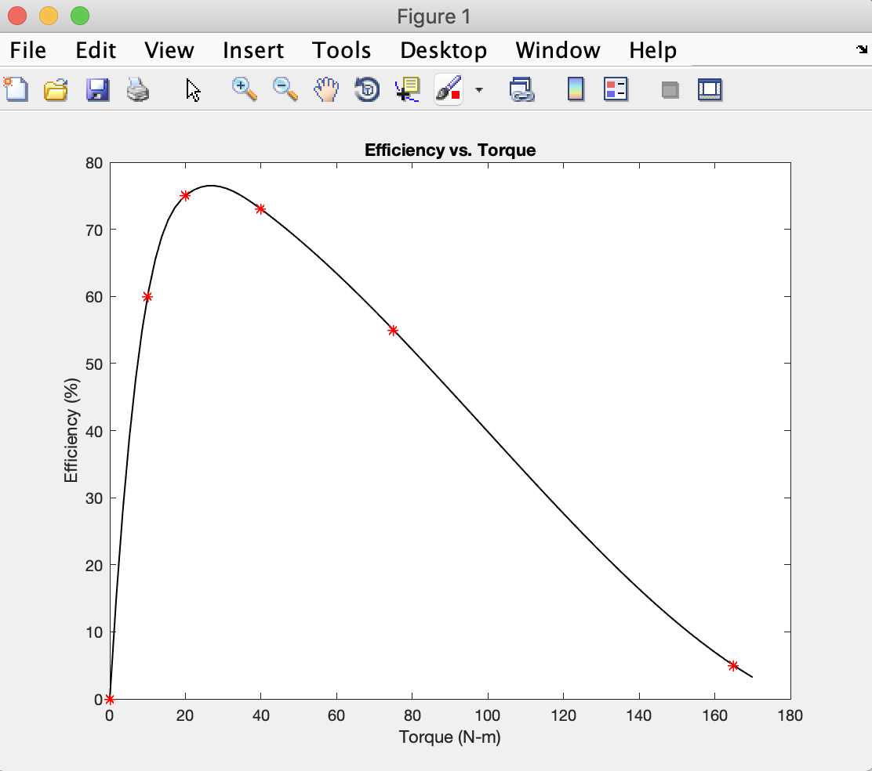

*Figure 2: Efficiency vs. Torque Graph*

After making observations based on the figure presented above, it is seen that as the torque increases to a certain point, the efficiency increases to about 75%. Once this maximum point is reached the efficiency begins to decrease for the continuing torques. Overall this plot shows the rover has highest efficiency while at a torque of approximately 25 Nm. After this point, the efficiency is not worth the higher force as it eventually has an efficiency of almost 0%. To maximize the efficiency, the torque should try to be maintained between 20 and 40 Nm.

**Task 8:**

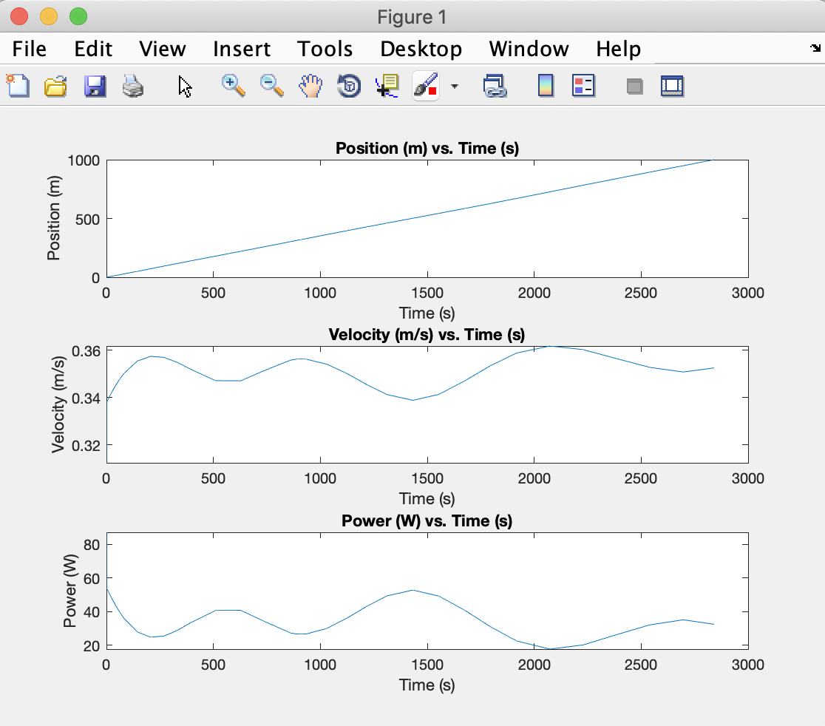

*Figure 3: rover_experiment1 Graph*

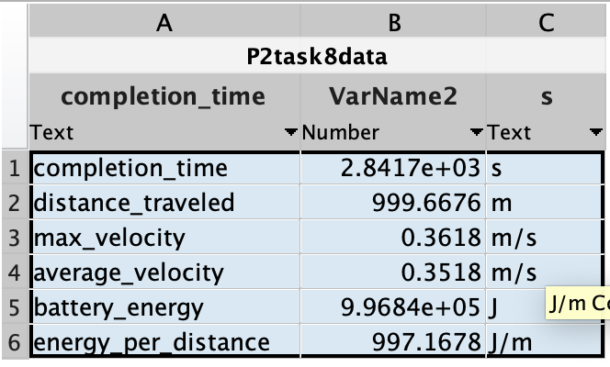

*Figure 4: rover.telemetry Data*

Based on the position versus time graph, Marvin the rover is traveling 1000 meters in 2841.7 seconds constantly. In the velocity versus time graph, it is seen that the velocity is trying to stay at a constant speed, however, with the mountainous terrain the rover is going over, this is nearly impossible. Once the rover hits a slope of any kind, the velocity will automatically increase or decrease depending on an uphill or downhill terrain angle. Looking at the power versus time graph, it is seen to be an inverse of the velocity versus time graph. This is reasonable due to when there is an increase in velocity on a downhill slope, there will be less power used. This can also be seen in the changes in figure 1 where the power increases and decreases with terrain angle.

**Task 9:**

The rover cannot complete the case defined in experiment1.mat using the 0.9072e6 [J] Lithium Iron Phosphate battery pack. As shown in figure 4, the battery energy used to complete experiment1.mat was 9.9684e5 [J], which is significantly larger than the proposed battery pack value.